**CloudWatch Alarms Assignment**

**(Shreyas Bhinge)**

**Problem Statement:**

**You work for XYZ Corporation. To maintain the security of the AWS account and**

**the resources you have been asked to implement a solution that can help easily**

**recognize and monitor the different users. Also, you will be monitoring the**

**machines created by these users for any errors or misconfigurations.**

**Tasks To Be Performed:**

**1. Create a CloudWatch billing alarm which goes off when the estimated**

**charges go above $500.**

**2. Create a CloudWatch alarm which goes off to an Alarm state when the**

**CPU utilization of an EC2 instance goes above 65%. Also add an SNS**

**topic so that it notifies the person when the threshold is crossed.**

1. Create a CloudWatch billing alarm which goes off when the estimated

charges go above $500.

Step 1: Choose **Create alarm**.

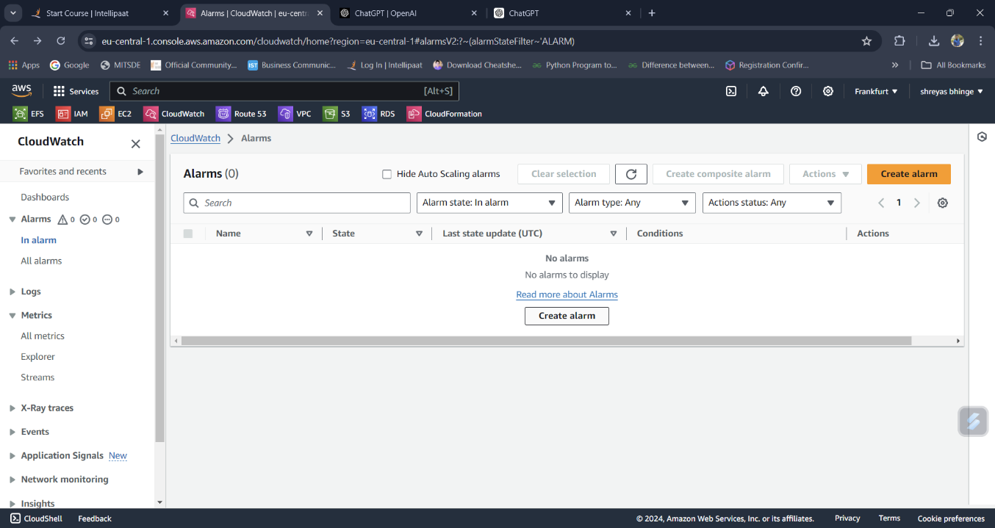

Step 2 : Choose **Select metric**. In **Browse**, choose **Billing**, and then choose **Total Estimated Charge**.

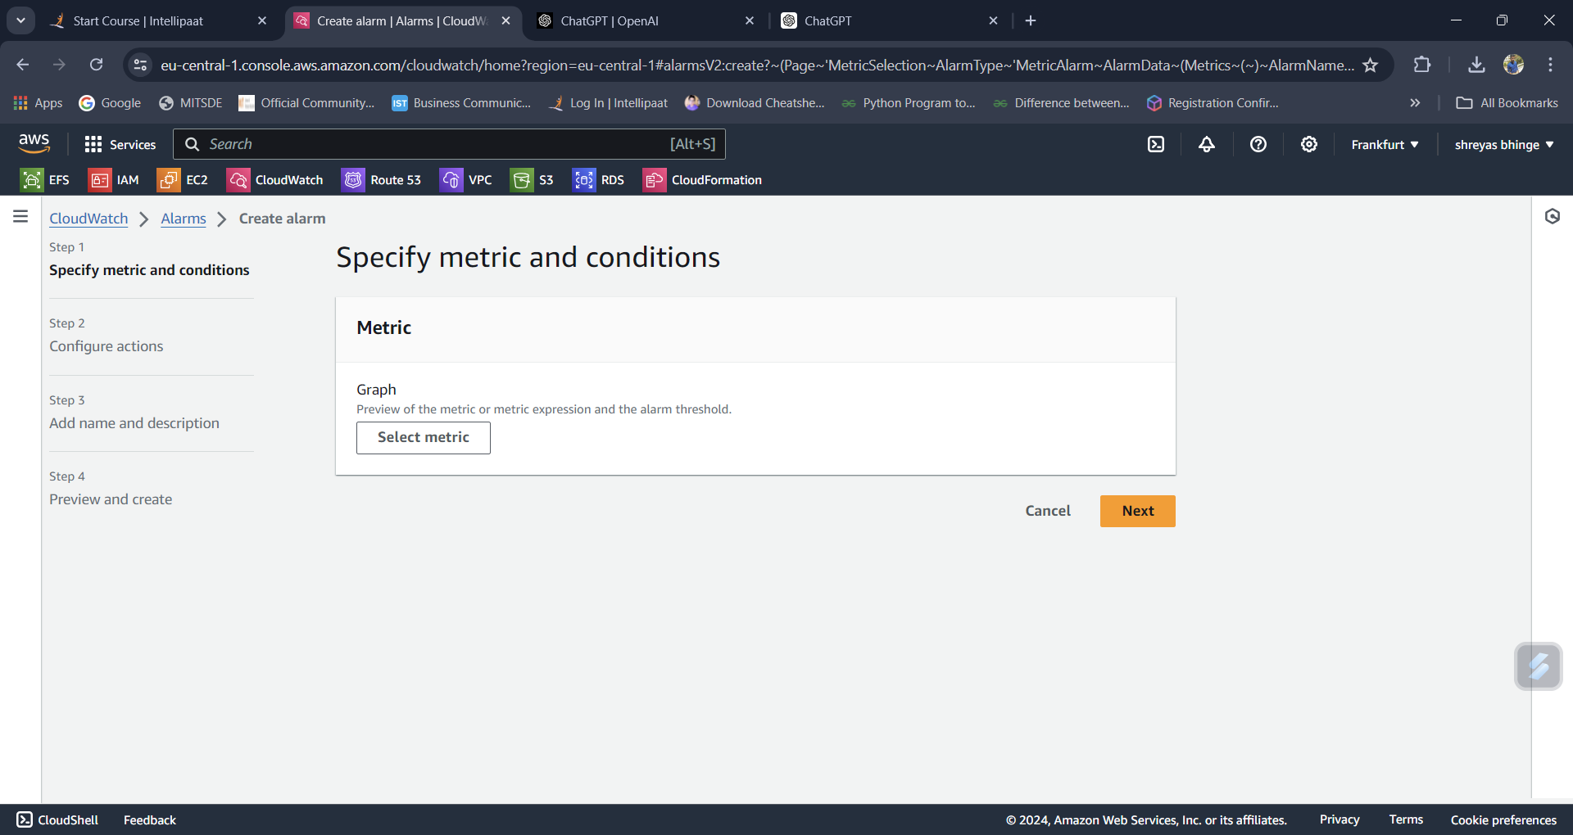

Step 3 : Select threshold type

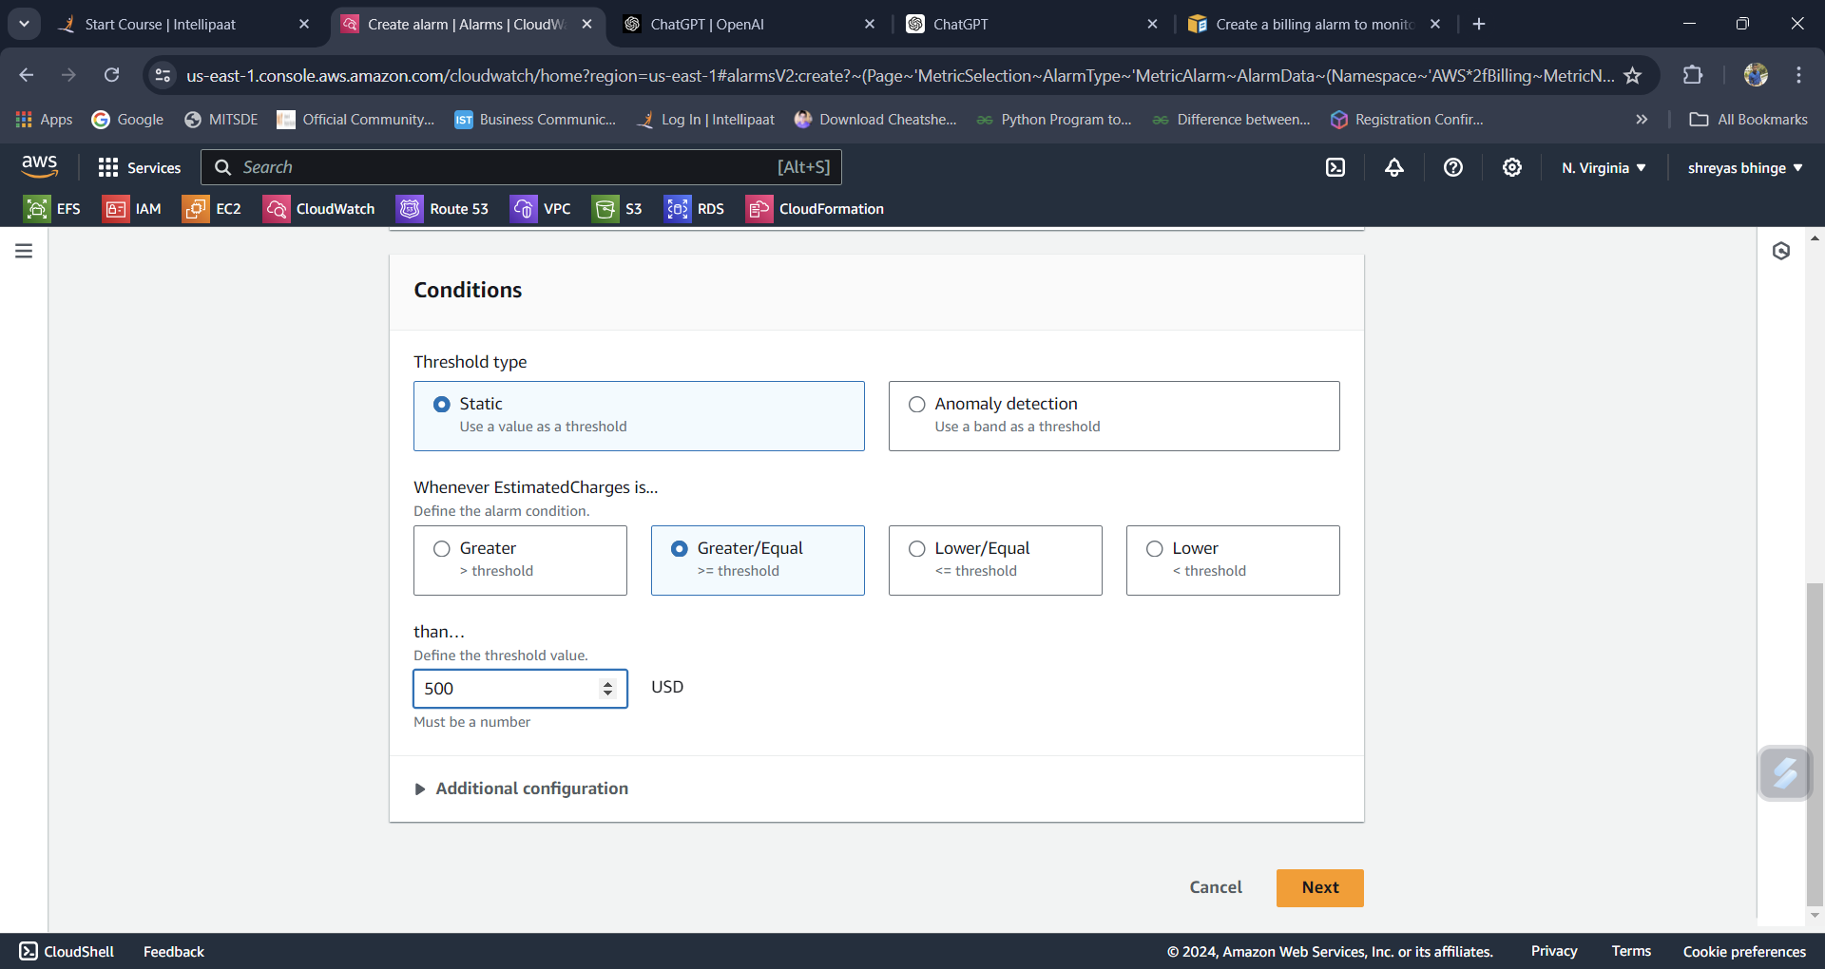

Step 4 : Select Estimation charges $500

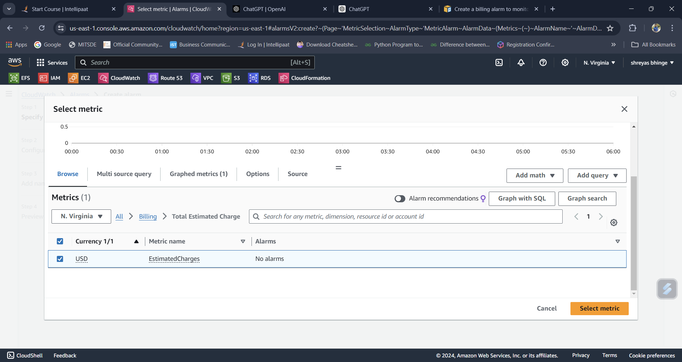

Step 5 : Select In alarm and SNS topic

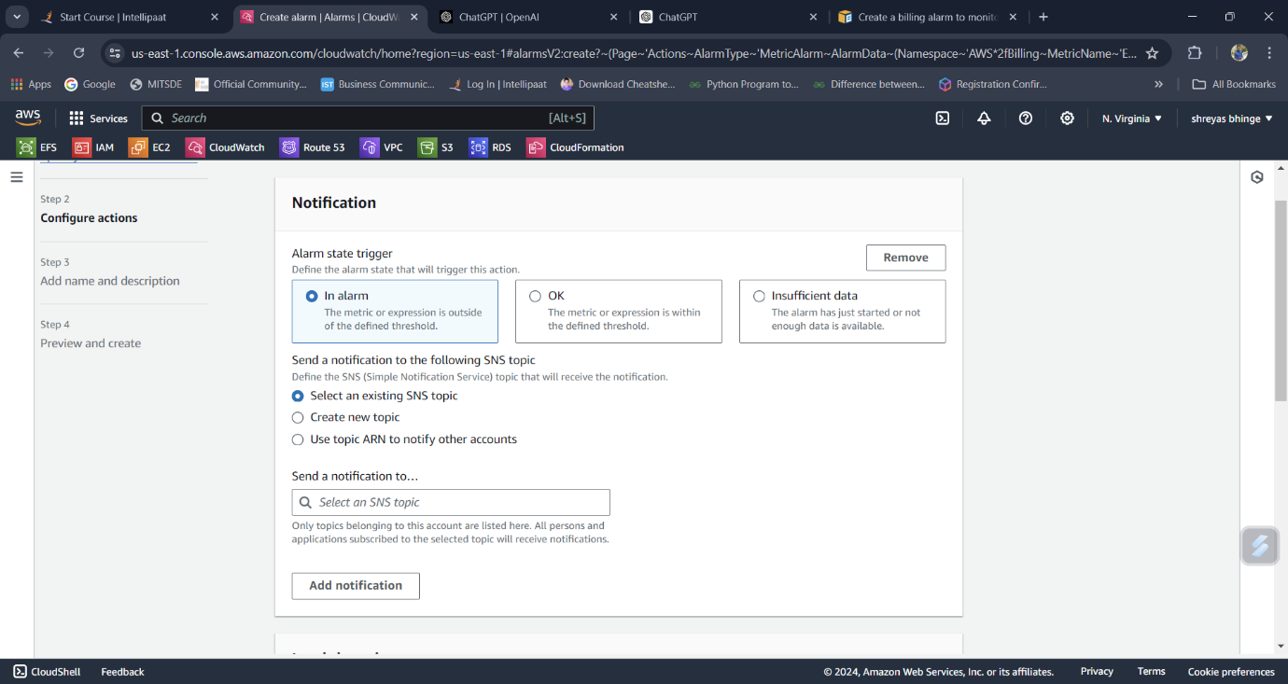

Step 6 : Add Billing name

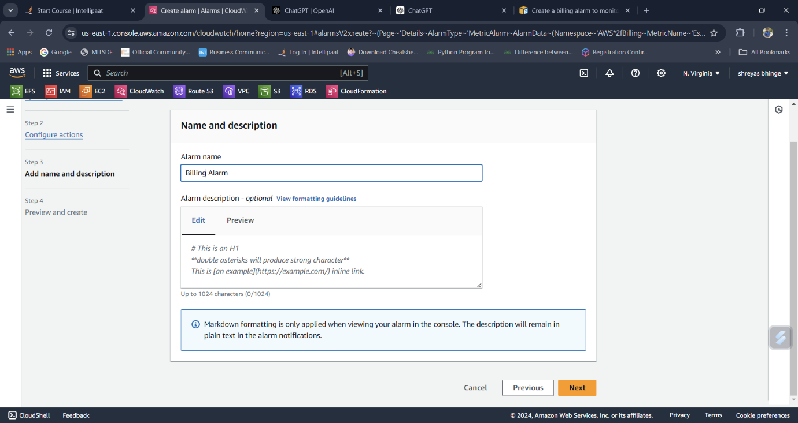

Step 7 : Billing Alarm created

